**Product page**

**هذه الصفحة شبيهة لموقع اكسباند كارت**

لرؤية وظائف عمل صفحة يمكنك زيارة موقع اكسباند كارت واستعمال اليوزر التالي:

<https://login.expandcart.com>

**Email**: [znairat@gmail.com](mailto:znairat@gmail.com)

**PW**: hnf89s8t

This page help users to add the products that needs to sell to their customers and the users always looking to this page to 6 things:

**Image**: helps them to know the product faster

**Product name:** includes name of each product

**Categories**: helps user to know the category for any product

**Price**

**Quantity**: This is very important for user to see it

**Statues**: this helps user to enable and disable the product to their customer

**Preview**: this help user to go directly to product page without losing too much time

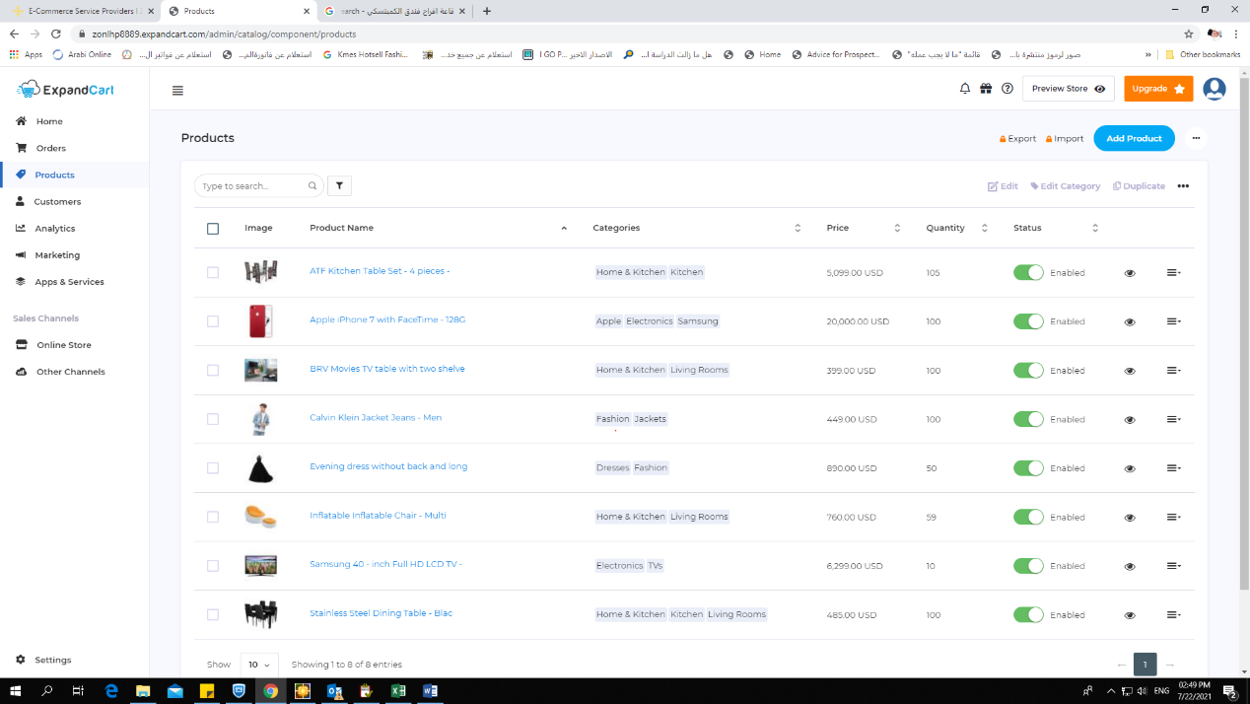

The information that each user need to fill must be as the picture below

Product name – Description - pictures – price – sale price after discount – cost price and margin profit for each item – Stock available – category – Variants – weight for shipping purposes – SEO

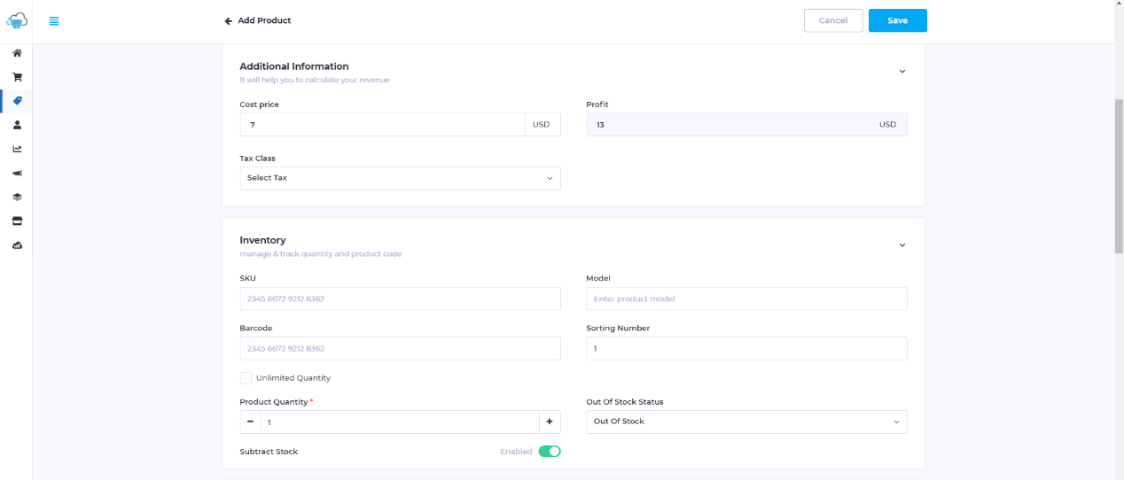



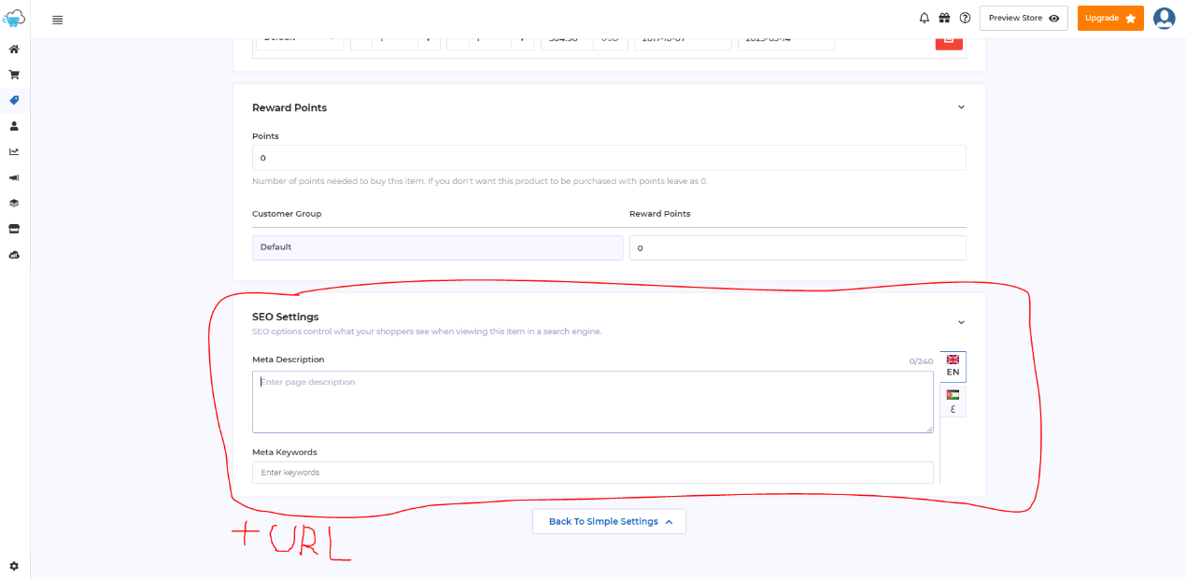

SEO will be as expandcart.com and we need to add URL as new option such as Shopify

